Workbook:

Mindfulness Based Intercultural Communication and Resilience Training (MBICRT)

University of Applied Science (FHWS)
Arriving at your own Door

It is indeed a radical act of love
just to sit down and
be quiet for a time
by yourself

Jon Kabat-Zinn

Content
1. Session: What is Mindfulness? 4
2. Session: Perception, Representation & Attention 9
3. Session: Mindfulness of Breath and Body in Movement 16
4. Session: Wherever you go, there you are… Our own patters of stress reactivity 20
5. Session: Mindful Responding instead of reacting 24
6. Session: Emotional Intelligence 32
7. Stressful communication 33
8. Session: Lifestyle Choices 36
9. Self-work: Working on unconscious biases 40
10. Sessions in presence: What is Culture? What Identity? 42
11. Sessions in presence: Resilience 45
12. Intercultural Communication 49
13. Session infinite: A mindful life 51
14. Exercises for in-between: 53
LITERATURE 55

Session: What is Mindfulness?

There is more right with us than wrong



Mindfulness-Based Stress Reduction (MBSR) is an eight-week course developed by Dr. Jon Kabat-Zinn at the University of Massachusetts Medical Center in Worcester.
MBSR is an intensive training in mindfulness, which Kabat-Zinn has defined as
“the awareness that arises by paying attention on purpose, in the present moment and non-judgmentally.”
Mindfulness is the capacity to be in the present moment without judgment. In daily lives, our minds are caught up in some aspects of past experiences or future plans. We construct stories in our minds as to how things should be or not be, remembering, worrying or hoping about somethings that might occur. Mindfulness teaches us how to observe these thoughts in the mind, not to identify with them. It is reminding us that we can chose to being more present experiencing fully each moment of our live, rather than being imprisoned by the dramas and thoughts we create in our minds. We learn to become more aware about our thoughts and our emotions without being subjected to them and learn to inhabit our body. Mindfulness is a way of looking deeply into oneself in the spirit of self-inquiry and self-understanding, breaking through destructive patterns of reaction to our experiences we have to face in live. We often cannot choose what happens to us. Yet, there is a choice in how we respond to it.

From the beginning, Kabat-Zinn and his co-workers did accompany his practice with research. MBSR has proven to be helpful in reducing symptoms and improving the quality of life for people experiencing a wide range of conditions, both physical and mental, including irritable bowel syndrome, fibromyalgia, psoriasis, anxiety, depression, and post-traumatic stress disorder. In the key areas — including depression, chronic pain, and anxiety — well-designed, well-run studies have shown very strong benefits for patients engaging in a mindfulness meditation program.

Mindfulness is not:

- It is not a relaxation exercise, although during or after the practice we may experience relaxation is not the aim.
- Mindfulness meditation is not an imaginative journey into dreams and fantasy and not about seeking enlightenment.
- It is also not about escaping from the world and our everyday reality. Rather, we practice being fully present in our lives as it occurs, even if it is uncomfortable or painful.

The triangle of awareness:

Sensation

Experience

Eexperie

Thoughts Emotions

The Indian and two wolves in his heart

An old Indian told his grandson about a tragedy that happened to his tribe some time ago and the grandson asked him: “How do you feel when you talk about it today?”
The old man replied, “It is as if two wolves are fighting in my heart. One wolf is revengeful and violent. He blames himself and the other, is very hurt and feels very angry. The other wolf is magnanimous, recognizes his pain and his feelings without blaming himself or the other, but is accepting what was happening as it happened and learns from it, full of belief in the good. Both wolfs are very strong in their emotions”
The grandson asked, "Which wolf will win the battle in your heart?"
"The wolf that I feed most with my attention and with my thoughts!" said the old man.

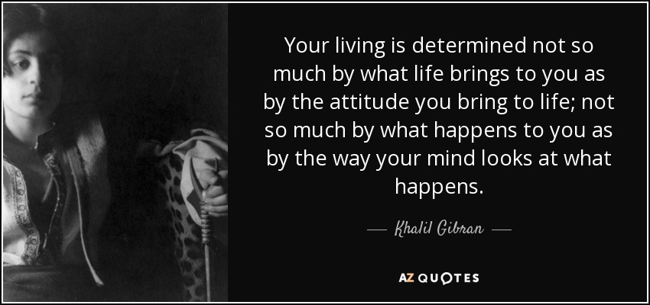

Homework after the Session 1:

- Practicing Body-Scan with the recording (or another recording at hand) for 6 from 7 days

- Practice eating one meal mindfully.

- Choose one routine activity and make a deliberate effort to bring moment to moment awareness to that activity each time you do it.

Session: Perception, Representation & Attention

How we perceive the world and ourselves

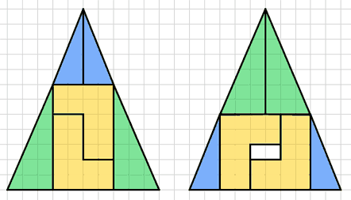

Theories and Models of realty strongly shape our perception of reality and our action within it. We organise reality in accordance with our personal and collective models, our inner maps, in such a constant manner, that we are often not aware about this act. Which means that we unconsciously or even sometime consciously act on basis of our maps as if they are the reality. And stumble over the moments, where others walk on the same territory with other maps in their head. As we tend to forget, that
the map is not the territory.
These maps are so important because they bring order into the million stimuli, we receive every moment, permit us to focus our attention and intension and allow us to give meaning to the world, meaning to us and meaning to our actions. These “maps of meaning” are largely shaped by our culture, by our societal upbringing, charged by our experience and the meaning we give to those experiences. They constitute neurological pathways and thus become somehow “engrained” into our daily lives. Yet, given the neuroplasticity of our brain, these pathways are never totally fixed and are always in the present moment open for alteration. Just like the cultural maps of meanings are. So, depending on which “map” we have installed, we focus on certain aspects of reality and ignore others. Just as if we wear glasses, with dissimilar lenses, which will then make us see the world differently.
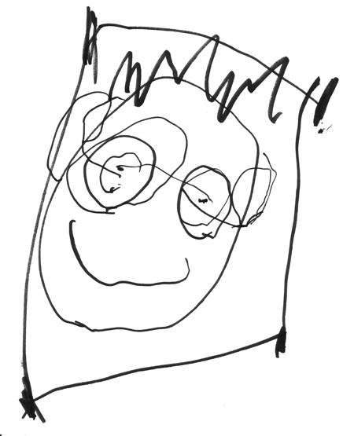
This is also valid for the image, the concept of ourselves, which largely shapes how we perceive ourselves, what we notice within us and what kind of relation we build to the outside world. These images of the self are also not given, but culturally shaped. (Experience different models)
What is central for this course, is to notice:

Aactual fact + B Interpretation = Experience of the event

Meaning and Representation
Central to understanding of representation and sense making is the concept of “social construction of reality” (Berger/Luckmann 1966). This model takes into consideration that humans can’t perceive reality without its meaning and that meaning is constructed inter-subjectively (ibd.23). By using things in particular ways, but also by naming things and events and representing them in a new context, meaning attributed to the material world and the events occurring.
“Representation is the process by which members of a culture use language (broadly defined as any system, that deploys signs, any signifying system) to produce meaning.” (Hall in Hall et al 2013: 45).
These representations include cultural artefacts (architecture, sights, instruments etc), images and sounds, and importantly: verbal language as a system of signs. As important insight, Saussure dismantles the sign into two elements: the signifier, which is the form (e.g. the word “tree” or the image: ) and the signified, the corresponding concept in your head with which the form is associated. This concept in your head functions as a “map of meaning” ordering signs. Both elements are required to produce meaning. Yet this meaning is not fixed, as signs do not own an intrinsic, essential meaning within themselves. There is no necessary, inevitable link between the signifier and the signified, the word tree and the concept of tree in our head. Rather, signs - as elements of a system- are defined by their difference to other elements of that system (“tree” is not “bee”). We create meaning with the help of our semantic networks, in which each word/sign is different to - yet also connected and associated with - another word/sign. The differences are of crucial importance for the creation of meaning. They are defined by social conventions specific to each society and each historical moment and thus always subjected to modifications, to “slippages” (Butler 1990) changing the signification. We create meaning by marking similarities to and differences from other things or experiences, as it is the “difference that signifies” (Hall in Hall et al 2013:17).

Maybe a visual?

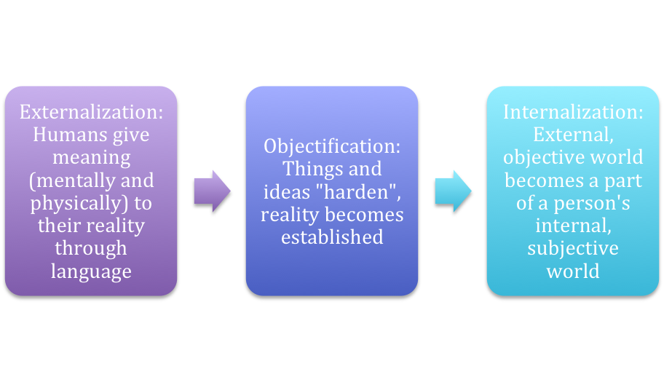
https://commons.wikimedia.org/wiki/File:Social_Construction_of_Reality.png

Literature to Representation & Meaning
Berger, P., Luckmann, T. 1966: The Social Construction of Reality: A Treatise in the Sociology of Knowledge
Butler, Judith (1997). "Further Reflections on Conversations of Our Time". Diacritics. 27 (1): 13–15. doi:10.1353/dia.1997.0004. S2CID 170598741
Hall, S., Evans, J., Nixon, S. (ed). 2013: Representation: Cultural Representations and Signifying Practice, London: Sage Pub.
Hall, Stuart 1980 "Cultural Studies: Two Paradigms." Media, Culture, and Society 2.
Hall, Stuart, ed. 1980 a. Culture, Media, Language: Working Papers in Cultural Studies, 1972-1979. London: Routledge, in association with the Centre for Contemporary Cultural Studies. https://archive.org/details/culturemedialang0000unse
hooks, bell 1994: Outlaw culture: resisting representations. Humanwissenschaften. Frankfurt am Main.
Ranta-Tyrkkö, S. 2011: High time for postcolonial analysis in social work, in Nordic Social Work Research June 2011; DOI: 10.1080/2156857X.2011.562032

The 8 foundational Attitudes of mindfulness:

- Non-judging

- Patience

- Beginner’s mind

- Trust

- Non- Striving

- Acceptance

- Letting go

8. Kindness and Self-compassion

In addition, humor, playfulness, generosity and gratitude are mentioned.

Pleasant events calender:
What was the experience? | Have you been aware, that it was a pleasant exper-ience? | Body sensations,  what did you notice? | Thoughts, what were you thinking? | Emotions,  what moods and feelings did you notice? | What thoughts, feelings are in your mind now as you write about this event?
Day 1

Day 2

Day 3

Day 4

Day 5

Day 6

Day 7

One can’t stop the waves of live, but one can learn to surf on them!

Indian proverb

Homework after Session 2:

- Body- Scan (with recording or without) on 6 of 7 days

- Completing the pleasant events calendar

Session: Mindfulness of Breath and Body in Movement

There is both pleasure and power in being present

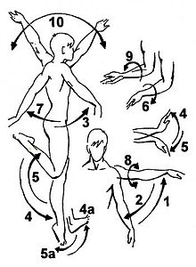

Unpleasant events Calendar:
What was the experience? | Have you been aware, that it was an unpleasant experience? | Body sensations,  what did you notice? | Thoughts, what were you thinking? | Emotions,  what moods and feelings did you notice? | What thoughts, feelings are in your mind now as you write about this event?
Day 1

Day 2

Day 3

Day 4

Day 5

Day 6

Day 7

Mindful Movement:

The intention is:
• To become aware of how it feels when we are not moving in the automatic pilot
• To keep coming back to the mountain position (sitting or standing) to feel the stillness, to be more in the state of BEING than in the state of DOING
• Do as many or as few exercises as you feel; preferably with one of the 8 + 2 attitudes of mindfulness

The attention is:
• Pause at the ends of the movement, explore personal boundaries and find a middle path
• Step out of the automatic pilot and into the experience of the movement itself
• Mindful movement is not about movement, even if it is the focus of consideration: It is about what body perceptions you become aware of, what feelings and thoughts.

The attitude is:
• Curious, tender and loving without having to achieve anything specific

Homework after Session 3:

    - Body- Scan (with recording or without) on 6 of 7 days
    - Mindful walking exercise (20min) put your timer or 3 times a day Breathing Space Meditation (see end of this bookled)
    - Completing the unpleasant events calendar

Session: Wherever you go, there you are… Our own patters of stress reactivity

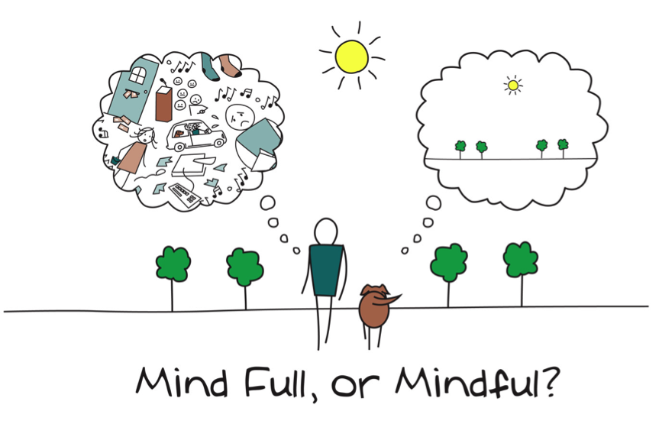
What is stress? In a medical or biological context stress is a physical, mental, or emotional factor that causes bodily or mental tension. Stress can be external (from the environment, psychological, or social situations) or internal (illness, or from a medical procedure). All external and internal factors that represent a potential threat, including physical pain and difficult emotions are called stressors or stress trigger. In situations we are confronted with a stress trigger, it activates the so-called stress reaction. Stress can initiate the "fight or flight" response, a complex reaction of neurologic and endocrinologic systems. Catecholamine hormones, such as adrenaline or noradrenaline, facilitate immediate physical reactions associated with a preparation for violent muscular action.
These include the following: Acceleration of heart and lung action, paling or flushing, or alternating between both, inhibition of stomach and upper-intestinal action to the point where digestion slows down or stops, constriction of blood vessels in many parts of the body etc. What is very important to note, that our bodes don’t know the difference between a real threat and an imagined threat so that scary movie is causing a very similar chemical reaction in our bodies as if we where there.
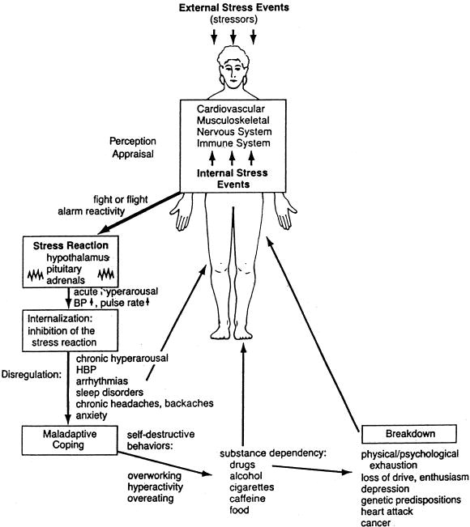
Source: Kabat-Zinn, Jon: 2013: Full catastrophe living, p.308
Gingerbread man:

Paradox of Mindfulness:
Acceptance brings Change!

Homework Session 4:

- Sitting Meditation on 6 of 7 days and writing down observations

- Mindful movement or mindful walking on 2 days a week

- Noticing automatic stress reactions – without the intension to change them; only observing one’s reaction to stress: What happens?

Session: Mindful Responding instead of reacting

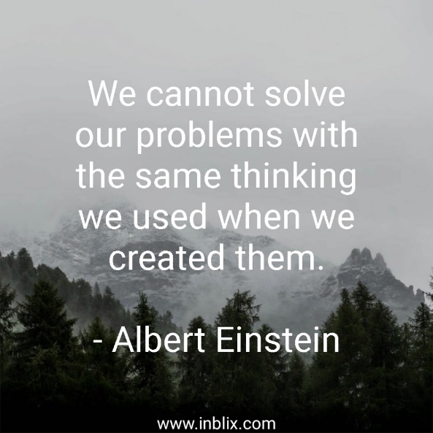

AWARENESS: Mindful-Stress Response
- Awareness of the Bodysensations, breathing, emotions and thoughts
- Calming the System
- Seeing new options

Source: Adapted from Kabat-Zinn, J.2013: The full catastrophe living, p.337
Stress, the Stress Reaction, and Stress Symptoms
• Stress is a dynamic event whose effects on an individual differ considerably.
• A distinction must be made between stress triggers (stressors) and a stress reaction.
• The stress reaction occurs on four levels: physiological, emotional, mental, and behavioral.
• Coping well with stress through activation of the stress response calls for addressing stress at all levels: physiological, emotional, mental, and behavioral.
• The physiological stress reaction — fight or flight — is an evolutionary response automatically triggered by a stressor.
• The intensity of the stress reaction depends largely on our assessment of the stressor — whether conscious or subconscious — and our stress-amplifying thoughts.
• The abilities and resources we attribute to ourselves in coping with stress play an equally important role in how stress affects us.
• Denial and repression are not helpful in this respect.
• Denial and repression do not reduce the stress reaction. Instead, they often lead to a situation of chronic stress.

Coping with Stress: The Stress Response
• An effective stress response requires a balance between activity and relaxation, meaning both physical relaxation (e.g., exercise) and mental (e.g., meditation).
• It is important to be aware of our stress-amplifying thoughts and the accompanying feelings, to find a way out of the stress spiral. This is where mindfulness can help.
• By practicing mindfulness, we can create space between a stress trigger and a stress reaction as we interrupt the process of going on automatic pilot and losing contact with the present moment. This allows for a conscious and wise choice rather than an unconscious, automatic reaction.

“A man is but a product of his thoughts. What he thinks he becomes!”
Mahatma Ghandi

Brain Integration Explanation by Tara Brach, PhD, gets into how mindfulness disrupts the neurobiology of fear https://www.nicabm.com/the-neuroscience-of-mindfulness-and-fear/
Polyvagal Theory (Stephen Porges)
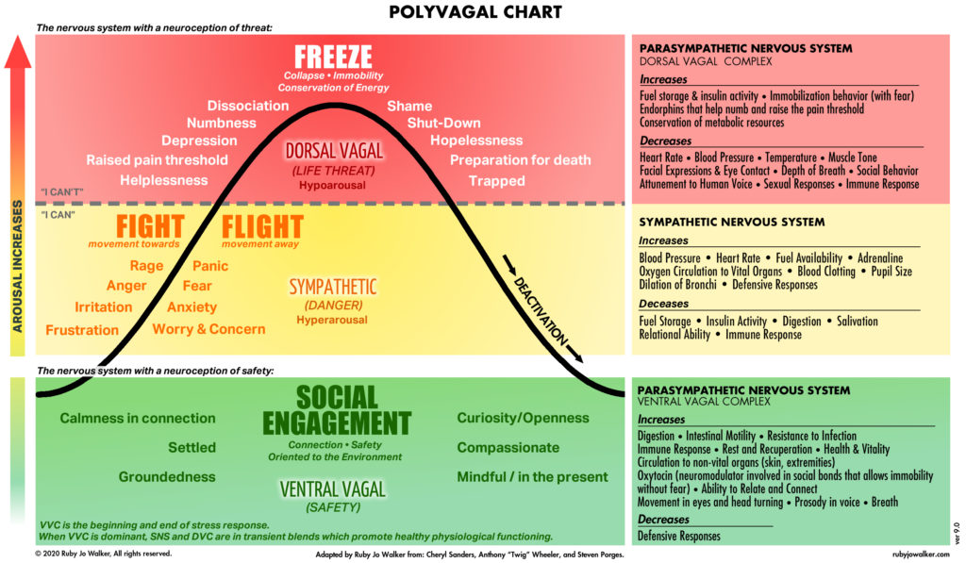

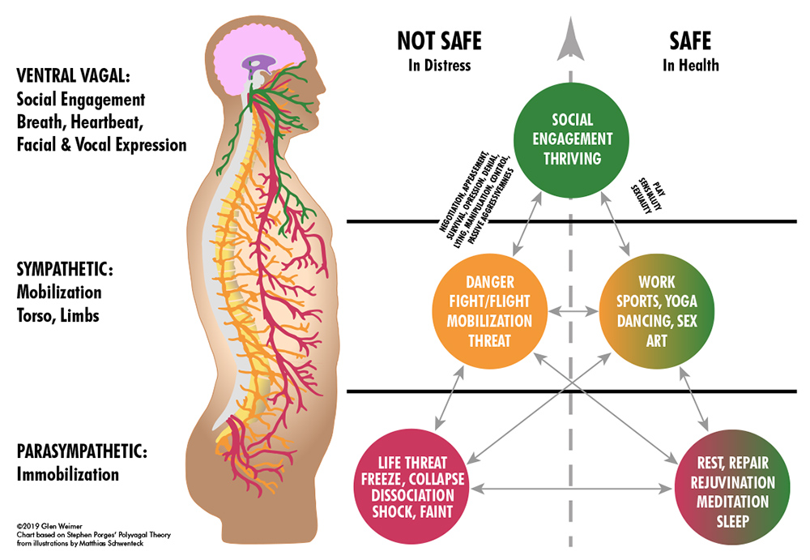Porges, Stephen W., The Pocket Guide to the Polyvagal Theory: The Transformative Power of Feeling Safe (2017)

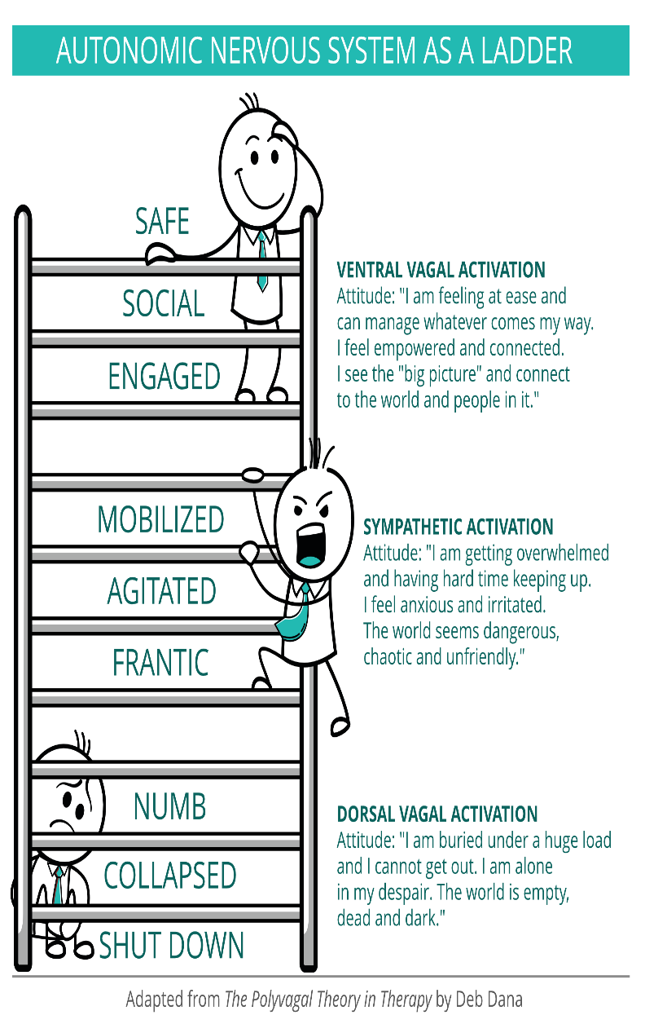 | 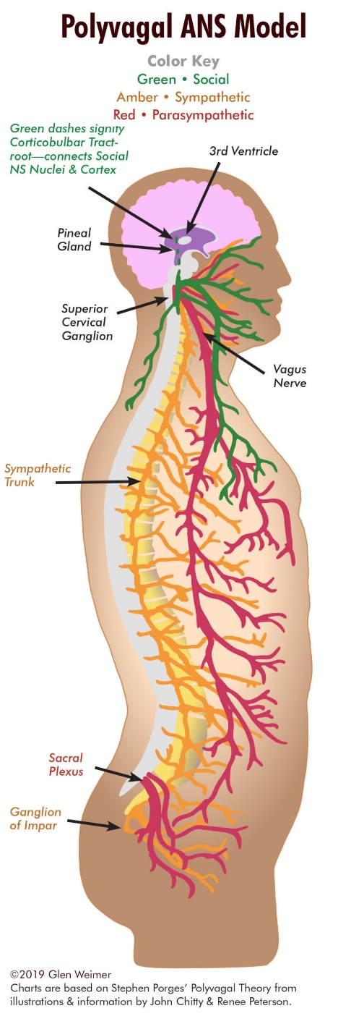
Our 10th cranial nerve is the Vagus nerve, which creates a direct line of communication between the brain and body. It is the crucial nerve for the switch in our Autonomic Nervous System (ANS). Dr. Stephen Porges described two separate vagal conduits: Ventral Vagal (green) which controls facial muscles, hearing, voice, heart and lungs (generally front of the body above the diaphragm); Dorsal Vagal (red) which controls brain stem, digestion and reproduction (generally below the diaphragm governing core survival functions). The third conduit is the Sympathetic Nervous System (SNS – orange) which comes off of a trunk or chain of nerves running alongside the spine at the level of the chest and low back (controlling mobilization of the torso, arms and legs to fight and flee). Dr. Porges, termed the the Ventral Vagal Complex (VVC) our Social Nervous System as it is only through our experience of safety that we are able to connect to our world. Safety is essential! Safety allows us to get close to others; proximity enables us to interact; that connection enables bonding; and this nexus empowers us to THRIVE!
How to map my nervous system? 1. What state I am in right now? Give it your own name or a colour! 2. What are the safety cues available HERE and NOW? (Exhale slowly; drinking warm water; sensing your body and the feet on the floor; smelling sth. nice, touching sth
Permission Sentences
Inner drivers / thoughts that increase stress are beliefs that run like a red thread through our lives and relationships. Although they have a great impact on our lives, we are usually not aware of them and therefore the have an even stronger effect. If we recognize our inner drivers/thoughts, we can counteract them with “permissible sentences” and weaken them.
“You need to be strong":
• I can be strong and have needs at the same time
• I can trust my feelings and let them guide me
• I can express feelings, or keep them to myself
• I don't have to impress anyone to be liked
• I can get help and ask for help

”You need to work hard”:
• I can accept my limits
• I can look forward to what I have achieved and relax
• I can get help
• I can proceed calmly and with a clear mind for what is necessary

“I have to be perfect to be loved/ respected”:
• I can sometimes make mistakes without feeling inadequate, and I can learn from them
• I am allowed to show myself as I am and develop my own style
• I can be forgiving when others make mistakes
• I don't always have to justify myself

“I have to please the others":
• I can take myself seriously and find out what I want myself
• I have the right to my own opinion
• I am allowed to think before doing it my way
• I am also okay when others are not satisfied with me
• I can do things the way I want to

“Hurry up":
• I can take my time and then do it my way
• I can get involved and enjoy
• I am allowed to observe my own rhythm

Pick a permission sentence or two that are particularly good for you. Then rephrase the sentence so that it fits your situation exactly and you really enjoy hearing it. You can also write the sentence on a piece of paper and hang it somewhere ... yet, be careful not to do this with appreciation and kindness towards yourself.

Difficult Communication Calendar
Briefly describe the situation: | What emotions where present for you? | What thoughts were present for you? | What body sensations were present for you? | What were your reactions? | What is here for you as you write this?

Homework after Session 5:

- Sitting Meditation: „Turning towards the difficult“, Body&Breath Meditation, Bodyscan or Mindful Movement on 6 of 7 days (40 Min)

- Bring your attention into stressful situations, and explore, if you can create a space between the stimulus and the reaction, to discover possibilities for conscious and creative responses

Session: Emotional Intelligence

Homework after Session 6 until next week:

- Develop your own self-care / mindfulness practice: What is good for you? (bodyscan, moving, walking outside, singing, m… ) 20 min per day!
- Complete the “Difficult communication Calendar”

Stressful communication

Interpersonal mindfulness



Elements of a mindful communication:

- I – Speech
- Silence
- Empathy
- Deep listening
- Gentle language
6.Truthful
….

Be aware about your own emotions and body sensations, while communicating with others. Labelling emotions is a powerful way to manage them and to behave skilfully in relationships. It helps to stay calm. E.g. if a man cannot say – at least to himself- :
“I feel ashamed” then it’s more likely to get angry and behave irrationally. The same with anger, if it’s named, it’s often easier not to become physically involved.
Brain research has revealed that finding words for feelings deactivates the part of the brain that initiates a stress response.

“Once you communicate with yourself, you’ll be able to communicate outwardly with more clarity” Thich Nhat Hanh

Homework after Session 7 until next week:

- Establish your daily 20- 45 min Self -care practice: meditation practice: Sitting-meditation, Bodyscan, mindful movement or walking (with or without recording) or other presencing practices

- Observe situations of stressful communication and your thinking, your sensations in the body and your emotions: just observing, not changing!

- Observe in your daily live: What is good for you and what not? How do you notice in your body, that you are stressed? What are your first warming signs?

Session: Lifestyle Choices

How can I best take care of myself and others?



Was do we take in?

Unhelpful strategies | Helpful strategies
Homework after Session 8:

- Establish your daily 20- 45 min Self -care practice: meditation practice: Sitting-meditation, Bodyscan, mindful movement or walking (with or without recording) or other presencing practices
- Taking care about you is the first step to take care about the others and the world…

Three steps for change:
1. Taking of consciousness
2. Decision
…. & 3.Action!


Self-work: Working on unconscious biases

Unconscious biases are biological pathways that are deeply embedded in our brains. They are shaped by our lives and our experiences. Once we have anchored a bias, we fall back into this pattern again and again, which reinforces this bias (Confirming Evidence Trap). We become increasingly blind to new "ways of thinking" to the right and left of these already existing paths.


With the Cognitive Bias Cheat Sheet, more than 170 unconscious biases were structured according to problem areas and processed graphically as Cognitive Bias Codex .


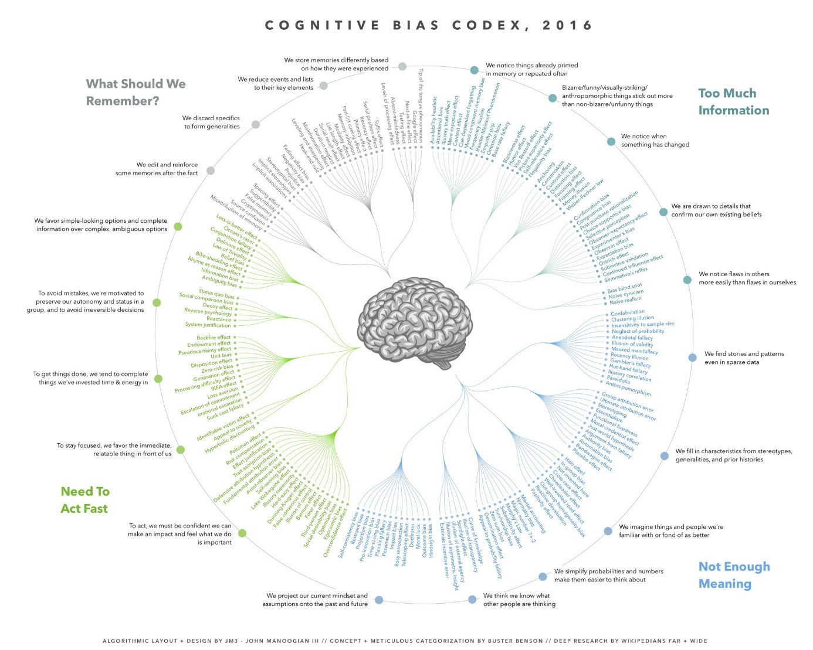
See the Video: Chimamanda Ngozi Adichie: The danger of a single story
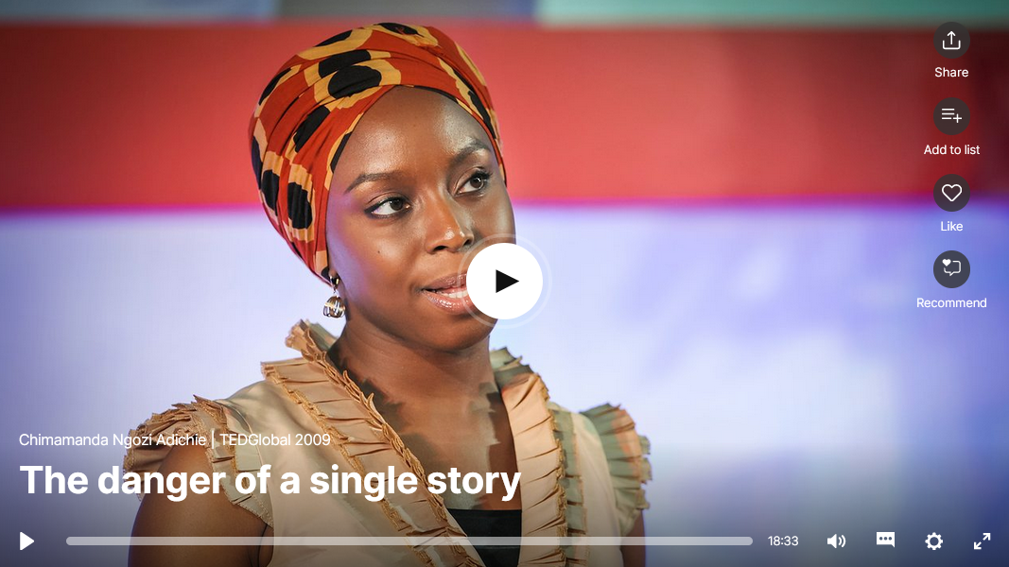
LINK

Four problems that biases help us address
Cognitive biases are just tools, useful in the right contexts, harmful in others. They’re the only tools we’ve got, and they’re even pretty good at what they’re meant to do. We might as well get familiar with them and even appreciate that we at least have some ability to process the universe with our mysterious brains.
Problem 1: Too much information.
There is just too much information in the world, we have no choice but to filter almost all of it out. Our brain uses a few simple tricks to pick out the bits of information that are most likely going to be useful in some way.
Problem 2: Not enough meaning.
The world is very confusing, and we end up only seeing a tiny sliver of it, but we need to make some sense of it in order to survive. Once the reduced stream of information comes in, we connect the dots, fill in the gaps with stuff we already think we know, and update our mental models of the world.
Problem 3: Need to act fast.
We’re constrained by time and information. Without the ability to act fast in the face of uncertainty, we surely would have perished as a species long ago. With every piece of new information, we need to do our best to assess our ability to affect the situation, apply it to decisions, simulate the future to predict what might happen next, and otherwise act on our new insight.
Problem 4: What should we remember?
There’s too much information in the universe. We can only afford to keep around the bits that are most likely to prove useful in the future. We need to make constant bets and trade-offs around what we try to remember and what we forget. For example, we prefer generalizations over specifics because they take up less space. When there are lots of irreducible details, we pick out a few standout items to save and discard the rest. What we save here is what is most likely to inform our filters related to problem 1’s information overload, as well as inform what comes to mind during the processes mentioned in problem 2 around filling in incomplete information. It’s all self-reinforcing..
Sounds pretty useful! So what’s the downside?
In addition to the four problems, it would be useful to remember these four truths about how our solutions to these problems have problems of their own:
- We don’t see everything. Some of the information we filter out is actually useful and important.
- Our search for meaning can conjure illusions. We sometimes imagine details that were filled in by our assumptions, and construct meaning and stories that aren’t really there.
- Quick decisions can be seriously flawed. Some of the quick reactions and decisions we jump to are unfair, self-serving, and counter-productive.
- Our memory reinforces errors. Some of the stuff we remember for later just makes all of the above systems more biased, and more damaging to our thought processes.

Nothing we do can make the 4 problems go away (until we have a way to expand our minds’ computational power and memory storage to match that of the universe) but if we accept that we are permanently biased, but that there’s room for improvement, confirmation bias will continue to help us find evidence that supports this, which will ultimately lead us to better understanding ourselves.

Sessions in presence: What is Culture? What Identity?

Preparation for Conflict, Culture and Transformation
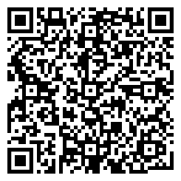
Please read:
Rathje, Stefanie. (2009). The Definition of Culture – An Application Oriented Overhaul. Interculture Journal: Online Zeitschrift für interkulturelle Studien. LINK

Multicollectivity describes the obvious but often neglected phenomenon that every human being simultaneously possesses multiple collective memberships, each offering differing cultural influences. The individual is able to add or cancel those memberships as well as switch between them depending on contextual relevance. If taken seriously, this concept fundamentally changes the way we perceive culture, individual identity, interculturality and intercultural competence.
Multicollectivity effectively defuses the cultural categories of country and ethnicity. It provides precise answers to the conflict of modern identity concepts that seem stuck between essentialism (“iceberg”) and dissolving (“flux”). Furthermore, multicollectivity reveals intercultural settings as radically subjective construction and helps redefine intercultural competence as transformative skill rather than adaptation or interaction skill.
Stefanie Rathje: multicollectivity. It changes everything, SIETAR Presentation Slides

Homework

1. See the Video: Taiye / Don't ask where I'm from, ask where I'm a local LINK (subtitles available)



2. Fill in the handout for yourself:
Don't ask where I'm from, ask where I'm a local [Taiye Selasi]
Rituals | Relationships | Restrictions
What daily rituals do I have? What do they stand for?  With which people in the world do I share them? | Which people, groups or relationships shape me? Which people make up my everyday emotional experiences and communications? | What restrictions do I experience? Are my will, my abilities and my freedom of movement restricted? Am I disadvantaged, discriminated against or hurt in my everyday life by racism or other attitudes?

Sessions in presence: Resilience

Resilience:
The ways people cope with adversity, fend off damage, and “bounce back” to normal functioning (Haidt, 2006). Beyond resilience lies the benefit of severe stress and post-traumatic growth (Haidt, 2006).

Being, Feeling and Resilience

Happiness
You—as a human: shaped by both nature (genes) and nurture
You—as you,: have the ‘raw materials’ to construct happiness
- Set-point: the brain’s default level of happiness (genetics)
- Conditions: facts about your life (internal/external)
    - things you cannot change: race, gender, ability/disability
    - things that you can change: wealth, where you live, relationship status
- Voluntary Activities: things you choose to do, which take effort + attention
(Haidt, 2016)



Happiness = Setpoint + Conditions + Voluntary Activities

(Haidt, 2016)

Suggested Book Read:
Haidt, Jonathan. The Happiness Hypothesis: Finding Modern Truth in Ancient Wisdom . Basic Books. Link

Adversity
- Adversity can lead to growth and increased happiness.
- People must encounter adversity to grow.
- Only people who have overcome great adversity can reach the highest levels of growth and development.

(Haidt, 2016)

Shows us our strength

Adversity
Key to moral and spiritual development
Strengthens our relationships
Force us to rebuild our lives; with a higher purpose
Material to write a rich life story
Allow us to develop wisdom, learned tacitly, through life experience
Shifts our Priorities
Filters our relationships
(Haidt, 2016)

Suggested Watch : The Power of Vulnerability-Brene Brown

Thinking, Doing and Resilience
Joseph Goldstein (1994) offers us an interesting analogy quoted by Zindel,Teasdale & Williams (2013).
“When we lose ourselves in thought, thought sweeps up our mind and carries it away, and in a very short time we can be carried far indeed. We hop a train of association not knowing that we have hopped on, and certainly not knowing the destination. Somewhere down the line we may wake up and realize that we have been thinking, that we have been taken for a ride. And when we step down from the train, it may be in a very different state of mind from where we jumped aboard. (pp. 59–60)” (Goldstein,1994).
According to Zindel, S., Teasdale & Williams (2013), we can relate differenlty to thoughts. “We free ourselves from the ruminative doing mode when we clearly see negative moods as passing states of mind, and negative thinking as the distorted products of those mind states. It is enormously liberating to realize that our ﻿thoughts are merely thoughts, even the ones that say they are not, and to recognize the contexts out of which they are born “(Zindel,, Teasdale & Williams, 2013).

﻿Thoughts, Actions and Consequences
Goldstein (1994) highlights that from thoughts come actions. “From actions come all sorts of consequences” (Goldstein, 1994). In which thoughts will we invest? Our great task is to see them clearly, so that we can choose which ones to act on and which simply to let be (GOLDSTEIN,1994)
We activate our thoughts and emotions in doing happiness. And doing happiness shapes our thoughts and emotions. What we think and how we feel, shape what we do. And what we do shapes what we think, how we feel (who we are). Consciousness is thought and emotion unified. It shapes our actions and our actions shape our consciousness

“Consciousness acts to guide and direct human activity. Activity acts to correct and develop a person’s consciousness” (Wozniak,1975).

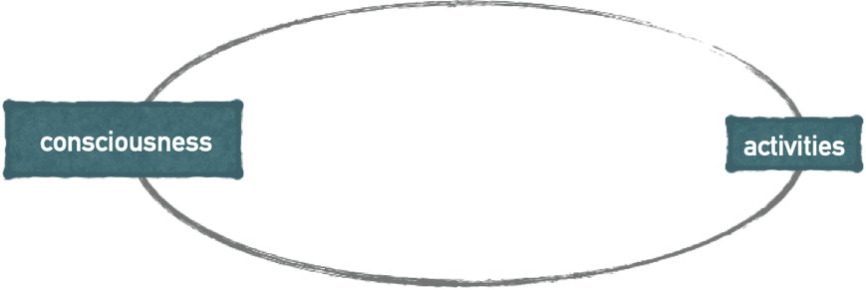

Suggested Book Read:
Segal, Zindel V.; Williams, Mark; Teasdale, John. Mindfulness-Based Cognitive Therapy for Depression, Second Edition (p. 303). Guilford Publications. Link

Intercultural Communication
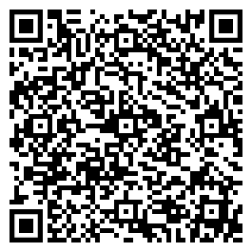
Please read for preparation:
Rathje, Stefanie. (2011). The Cohesion Approach of Culture and its implications for the Training of Intercultural Competence. Journal Advances in higher education. 95-114. LINK

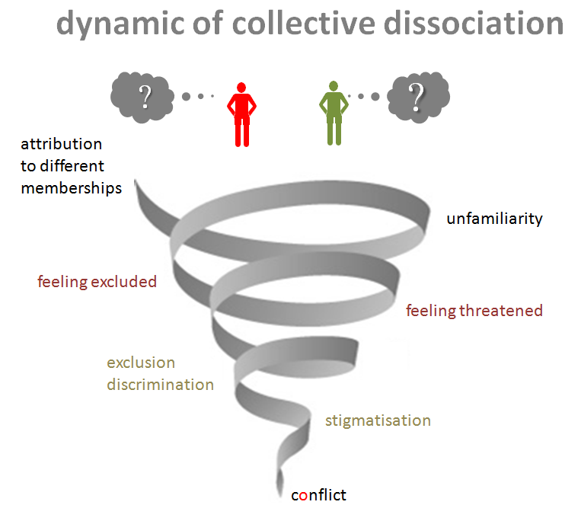
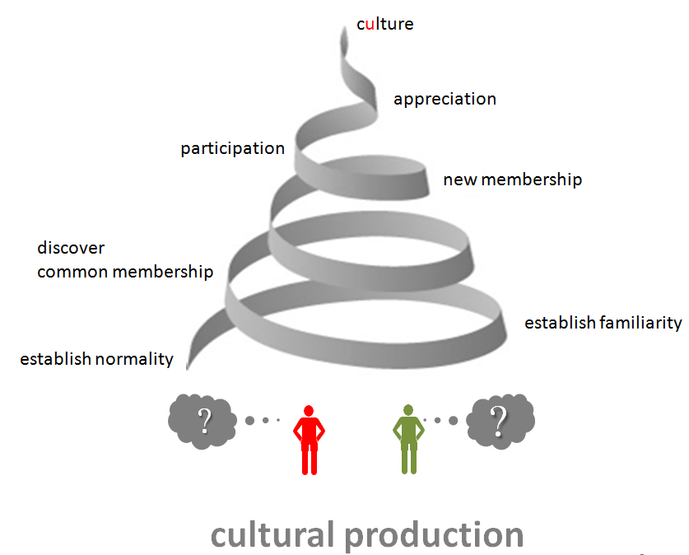

Idea for the graphic by: Stefanie Rathje: multicollectivity. It changes everything, SIETAR Presentation Slides

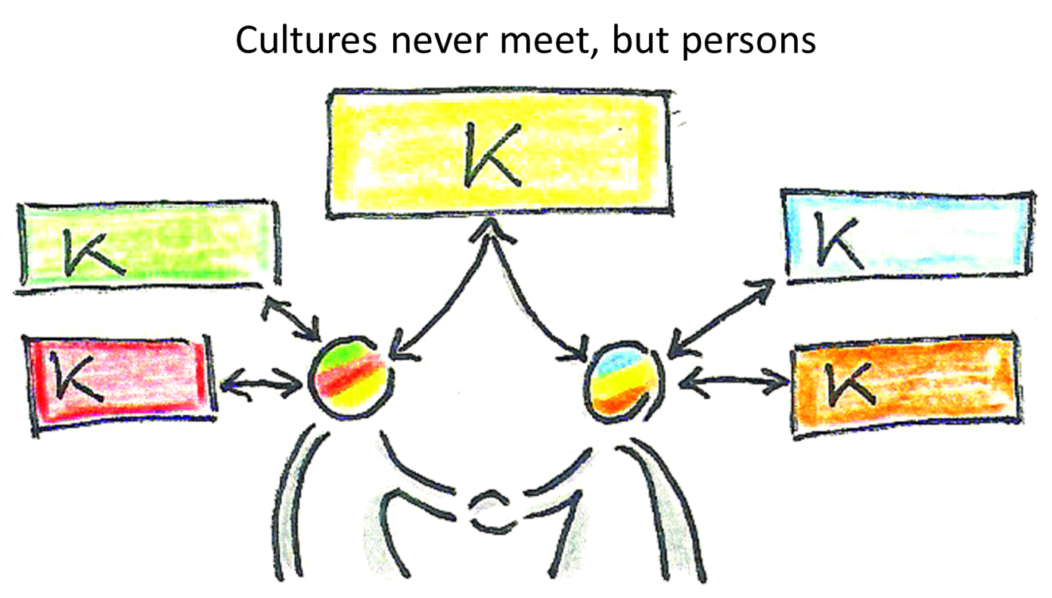

Session infinite: A mindful life

Farewell and New Beginning



Exercises for home:

- Create your routine and give them relevane & importance (Sitting meditation, Bodyscan, mindful movement, with or without regording); the effects will be nourishing your whole family! Patience!

- Create spaces, for you to breath, to be alone with yourself, to contemplate … to fully be present….in your own life!

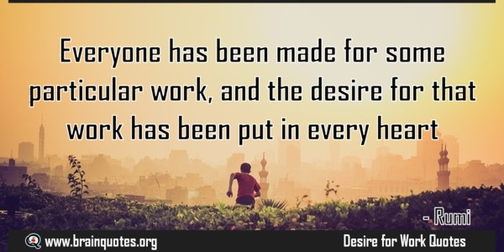

Exercises for in-between:

BreathingSpace Exercise:
The image of the breathing space exercise is that of an hourglass:
1. One becomes aware of the situation and comes to the present moment, perceiving everything in the here and now (openly). What are you thinking? What are emotions? What are the body sensations? (Awareness)
2. Then one gathers the scattered mind by focusing on the breath, feeling the breath. Here you can take a few inhalations and exhalations to collect the scattered mind. Focussing, calming.
3. You open your awareness of breathing to feeling the body as a whole, feeling your feet on the ground. Open yourself to all your senses. Watch your experience as best you can with curiosity and friendliness.

RAIN
R - Recognise / Realize: What is going on with you right now? What are you thinking? What do you feel right now? And what do you sense in your body?
A- Acceptance / Acknowledging all, what is here with your right now? Open yourself to experiencing it fully, just how it is.
I-Interest / Become interested to look deeper into the experience: What happens in my body? Is this changing? Where do I feel it? If I have noticed an emotion, where precisely do I sense it in my body and how?
N-Non-Identify / Become aware, that you are not these emotions, you are not these thoughts; you simply experience these thoughts or emotions right now…

GLAD
G – Grateful: Become aware, what are you grateful for?
L – Learning: What have you been learning today or the last days?
A – Accomplishment: Become aware, that you have for sure accomplished something… What was this? What did you accomplish today or the last days?
D – Delight: Become aware about something, that makes you feel delight… it can be something very small, but somehow it feels good to think about it…

S.T.O.P.
S top: Stop and become aware
T une in: Take a couple of breaths to tune into the present moment
O pporunity: Become aware, that you have the possibility, the opportunity to react differently, e.g. It’s ok to feel hurt… and I breath into it… Or: Yes, it’s ok that he thinks this way... that this is his opinion…
P ossibility: Congratulation! With mindfulness, you will make use of the possibilities to identify your patters of reaction. Knowing, that you can change yourself, but not the others. And here you will find many possibilities: So you can liberate yourself to act freely – not automatic- and create spaces for creative action, true self-expression and well-being.

LITERATURE

Mindfulness:
Kabat-Zinn, J. 1990: Full Catastrophe Living: Using the Wisdom of our Body and Mind to Face Stress, Pain and Illness. Delta.
Kabat-Zinn, J. 1994: Wherever you go, there you are: Mindfulnessmeditation in everyday life. New York.
Kabat-Zinn J. 2003: Mindfulness-based interventions in context: past, present, and future. Clinical Psychology: Science and Practice,10: 144–156.
Kabat-Zinn, J. 2005: Coming to Our Senses: Healing Ourselves and the World Through Mindfulness. New York: Hachette; Mindfulness; pp. 108–113.
Shapiro, S., Siegel, R., Neff, K.D. 2018: Paradoxes of Mindfulness. Mindfulness 9, 1693–1701. https://doi.org/10.1007/s12671-018-0957-5
Segal, Z.V., Williams, J.M.G., Teasdale, J.D., 2002: Mindfulness.Bsaed Cognitionve Thearpy for Depression : a new approach to preventing relapse, New York.
Williams, J.M.G., Teasdale, J.D., Segal, Z.V., Kabat-Zinn, J. 2007: The Mindful Way through Depression: freeing yourself from chronic unhappiness. New York.

Unconscious biases
Banaji, Mahzarin/Greenwald, Anthony G. (2013). Blind Spot: Hidden
Biases of Good People.
Todorov, Alexander. (2017). Face Value: The Irresistible Influence of First Impressions.
Agarwal, Pragya. (2020). Sway: Unravelling Unconscious Bias.
Steele, Claude M. (2011). Whistling Vivaldi: How Stereotypes Affect Us and What We Can Do.

Culture
Rathje, Stefanie. (2009). The Definition of Culture – An Application Oriented Overhaul. Interculture Journal: Online Zeitschrift für interkulturelle Studien. LINK
Welsch, Wolfgang: Transculturality - the Puzzling Form of Cultures Today, from: Spaces of Culture: City, Nation, World, ed. by Mike Featherstone and Scott Lash, London: Sage 1999, 194-213. LINK
Kidd, Warren/Teagle, Alison (2012). Culture and Identity (Skills-based Sociology)
Han, Byung-Chul (2022). Hyperculture: Culture and Globalisation.

Resilience & Emotional Intelligence
Baran Metin,U., Maria, C., Peeters, W. & Toon W. Taris (2018) Correlates of procrastination and performance at work: The role of having “good fit”, Journal of Prevention & Intervention in the Community, 46:3, 228-244, DOI: 10.1080/10852352.2018.1470187

Berceli, D. (2005). Trauma Releasing Exercises (TRE): A revolutionary new method for stress/trauma recovery, Charleston.
Goldstein J (1994). Insight meditation: The practice of freedom. Boston: Shambhala.
Levine, P. (1997) Waking the Tiger: Healing Trauma. The Innate Capacity to Transform Overwhelming Experiences, New York.
Neff, K. D. (2009). The role of self-compassion in development: A healthier way to relate to oneself. Human Development 2009;52:211–214. DOI: 10.1159/000215071
Porges SW (2017). Die Polyvagal-Theorie und die Suche nach Sicherheit: Traumabehandlung, soziales Engagement und Bindung. .Lichtenau/Westphalia, German: Probst Verlag.
Porges SW (2017). The Pocket Guide to the Polyvagal Theory: The Transformative Power of Feeling Safe. New York: WW Norton.
Porges, S. (2017) The Pocket Guide to the Polyvagal Theory: The Transformative Power of Feeling, New York.
Wise, J. (2009) Extreme Fear: The Science of Your Mind in Danger, New York.
Zindel,V. S., Teasdale, J. D. & Williams, J. M. G. (2013). Mindfulness-based cognitive therapy for depression. Second Edition. Guilford Publications.

Intercultural-communication
Rathje, Stefanie. (2011). The Cohesion Approach of Culture and its implications for the Training of Intercultural Competence. Journal Advances in higher education. 95-114. LINK
Rathje, Stefanie. (2007). Intercultural Competence: The Status and Future of a Controversial
Concept. Language and Intercultural Communication 7 (4), 254-266. LINK

Holliday, Adrian/Kullman, John/Hyde, Martin. (2021). Intercultural Communication: An Advanced Resource Book for Students.
Lanier, Sarah A. (2000), Foreign to Familiar: A Guide to Understanding Hot - And Cold - Climate Cultures.

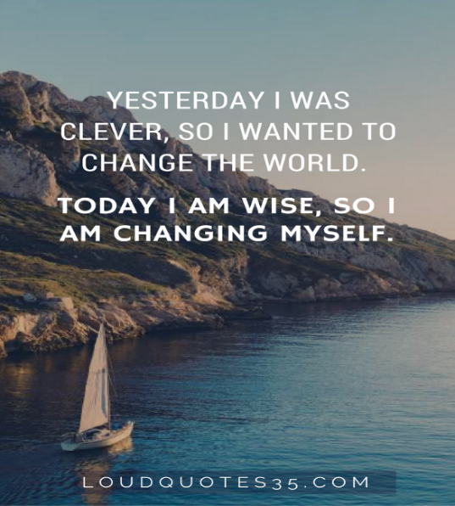

This in hand working book builds on the „Stress Reducation Programm (MBSR)“ , which is developed by Prof. Dr. Jon Kabat-Zinn and his team at the „Center for Mindulness in Medicine, Health Care and Society“ in the medical faculty of the university of Massachusetts in Worcester, MA USA. It refers to the course book from: Woodward, B.: 2019: Course Workbook Mindfulness MBSR, Mindful Academy Solterreno.
Kabat-Zinn J. Mindfulness-based interventions in context: past, present, and future. Clinical Psychology: Science and Practice. 2003;10:144–156, p.145.
This is thus distinct from a reflective approach to representation, in which language conceptualized as a like a mirror, reflecting the true meaning of an object, person, idea or event and is also different to an intentional approach, in which the words only mean what the author intends them to mean.
Lehrhaupt, L., Meibert, P. 2017: Mindfulness-Based Stress Reduction: The MBSR Program for Enhancing Health and Vitality, New World Library, p.37

